VSCode error correction:

**Set-ExecutionPolicy RemoteSigned -Scope Process**

**1. Install Python (if not installed)**

Make sure Python is installed.

Check version:

**python --version**

If not installed, download it here: [**https://www.python.org/downloads/**](https://www.python.org/downloads/)

**2. Set up a virtual environment**

# Create

**python -m venv env**

# Activate

# On Windows:

**env\Scripts\activate**

3. **Install Django**

Install Django using pip.

**pip install Django**

4. **Create the Django project**

Create your main project folder.

**django-admin startproject myproject**

**cd myproject**

You should see:

**myproject/**

**├── manage.py**

**└── myproject/**

**├── __init__.py**

**├── settings.py**

**├── urls.py**

**└── wsgi.py**

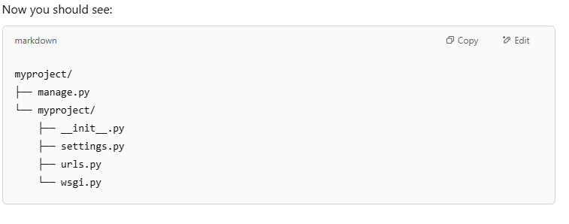

5. **Run the development server**

**python manage.py runserver**

6. **Create an app**

**python manage.py startapp myapp**

what are the **settings.py configurations** to do based on the libraries/frameworks/modules used?

Register the app in **myproject/settings.py:**

**INSTALLED_APPS = [**

**...**

**'myapp',**

**]**

7. **Start building your app**

You can now begin:

* Adding models to **myapp/models.py**
* Creating views in **myapp/views.py**
* Creating templates and static files
* Updating **myproject/urls.py** to include app routes

8. **Migrations & DB setup**

Run migrations to set up the database:

**python manage.py makemigrations**

**python manage.py migrate**

9. **Create a superuser (admin)**

**python manage.py createsuperuser**

Then visit:  
**http://127.0.0.1:8000/admin**

**Tips**

**pip install -r requirement.txt**

where requirement.txt is a text file with all the require libraries to install. These are some requirements below:

asgiref

Django

django-cors-headers

djangorestframework

djangorestframework-simplejwt

PyJWT

pytz

sqlparse

psycopg2-binary

python-dotenv